Automatic Toll Gate

The idea is very simple, it is an automatic toll gate which permits the vehicle passing in front of the sensor to open the gate with the help of the servomotor, and has a delay of 3 seconds after the car passed the sensor to close.

**The components I used**

Jumper wires

Arduino Uno

Ultrasonic Module

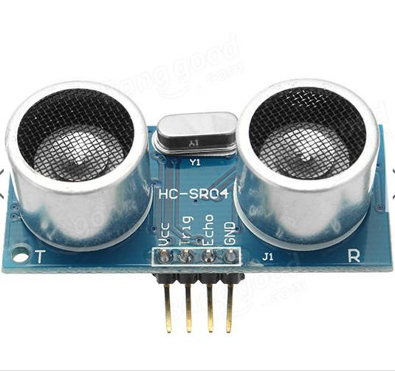

Servomotor SG90

Cardboard

**Arduino Code**

**Project Images**

In the cardbox the have the ultrasonic module, and on the left is the servomotor with an gate made of cardbox.



